Horizon 2020 – “Unleashing Student Potential”

Every important journey begins with a destination in mind and starts with a clear view of the horizon ahead. The Horizon 2020 strategic plan for Albemarle County Public Schools is designed to unleash each student’s potential and equip them for success both now and in the future. To do this, we aim to foster deep learning experiences that develop essential competencies like communication, collaboration, creativity, critical thinking and problem-solving. We seek to inspire the natural curiosity of our students, not through compliance and testing, but by cultivating engaging learning environments, hands-on learning experiences, and real-world learning opportunities. These are important to us and our larger community as evidenced by feedback in our recent strategic plan review.
As we reflect on our strategic direction, we imagine what the world will be like when our entering kindergarten students graduate and what skills they will need to thrive in the future. For Albemarle County Public Schools, our destination is a place where every graduate leaves our schools prepared for a lifetime of learning in a rapidly changing world. Successful navigation of the route requires unity of purpose among those making the journey and dedication to following an established plan. The Albemarle County Public Schools Strategic Plan guides us towards the horizon.

Our Vision
All learners believe in their power to embrace learning, to excel, and to own their future.
Our Mission
The core purpose of Albemarle County Public Schools is to establish a community of learners and learning, through relationships, relevance, and rigor, one student at a time.

Our Core Values
Excellence
We believe in meaningful learning that stretches people to the frontiers and boundaries of their abilities.

Young People
We believe young people deserve the best we have to offer. Each individual child is capable and has the right to safety, mutual respect, and learning.

Community
We believe in our collective responsibility to work together in a cooperative effort to achieve common goals by building communities of practice, establishing a high quality learning community, and listening to the community.

Respect
We believe in treating all individuals with honor and dignity.

Our Lifelong-Learner Competencies
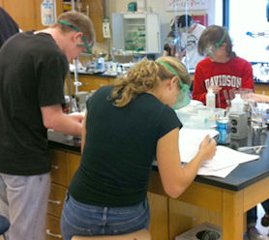
Lifelong learning places emphasis on results. To develop the skills and habits associated with lifelong learning, students must: learn beyond the simple recall of facts; understand the connections to and implications of what they learn; retain what they learn; and be able to apply what they learn in new contexts.
- Plan and conduct research.
- Gather, organize, and analyze data, evaluate processes and products; and draw conclusions.
- Think analytically, critically, and creatively to pursue new ideas, acquire new knowledge, and make decisions.
- Understand and apply principles of logic and reasoning; develop, evaluate, and defend arguments.
- Seek, recognize and understand systems, patterns, themes, and interactions.
- Apply and adapt a variety of appropriate strategies to solve new and increasingly complex problems.
- Acquire and use precise language to clearly communicate ideas, knowledge, and processes.
- Explore and express ideas and opinions using multiple media, the arts, and technology.
- Demonstrate ethical behavior and respect for diversity through daily actions and decision making.
- Participate fully in civic life, and act on democratic ideals within the context of community and global interdependence.
- Understand and follow a physically active lifestyle that promotes good health and wellness.
- Apply habits of mind and metacognitive strategies to plan, monitor, and evaluate one's own work.
Our primary focus is on teaching and measuring the lifelong-learner competencies our students need to thrive as 21st century learners, producers, and citizens. All ACPS students will be…
Our Desired Outcome for Each Student
- *Academically accomplished;
- Effective communicators and collaborators who are confident in themselves and respectful of others;
- Globally aware, independent, responsible learners and citizens;
- Critical and creative thinkers, innovators and problem solvers;
- Technologically capable; and
- Ready to own their future.
*Defined as broader than just core subjects. See Quality Assurance Indicators, p.6

All Albemarle County Public Schools students will graduate having actively mastered the lifelong-learning skills they need to succeed as 21st century learners, workers and citizens.
One Student-Centered Strategic Goal

Our baseline measurable indicators of goal attainment for Horizon 2020 will be focused on:
Percentage of a given class and percentages of enrollment groups who completed a credential within four years, a measure also known as the on-time graduation rate. In addition, progress towards this goal will be measured using the Cohort Completion Rate published by the Virginia Department of Education (VDOE) which includes all diploma types, GEDs and Certificates of Completion.

ACPS will consider students' graduation or completion of a credential as baseline evidence that they have mastered the lifelong-learner competencies needed to succeed as 21st Century learners, workers and citizens as a result of the curriculum design and opportunities provided throughout their educational career in the school division. To measure our progress towards our one student-centered strategic goal, we will strive to increase both our on-time graduation rate and cohort completion rate to 97% or more by 2020. This represents a 5% increase in the 2012 on-time graduation rate and a 3.2% increase in the 2012 cohort completion rate. Our five year trends are as follows:

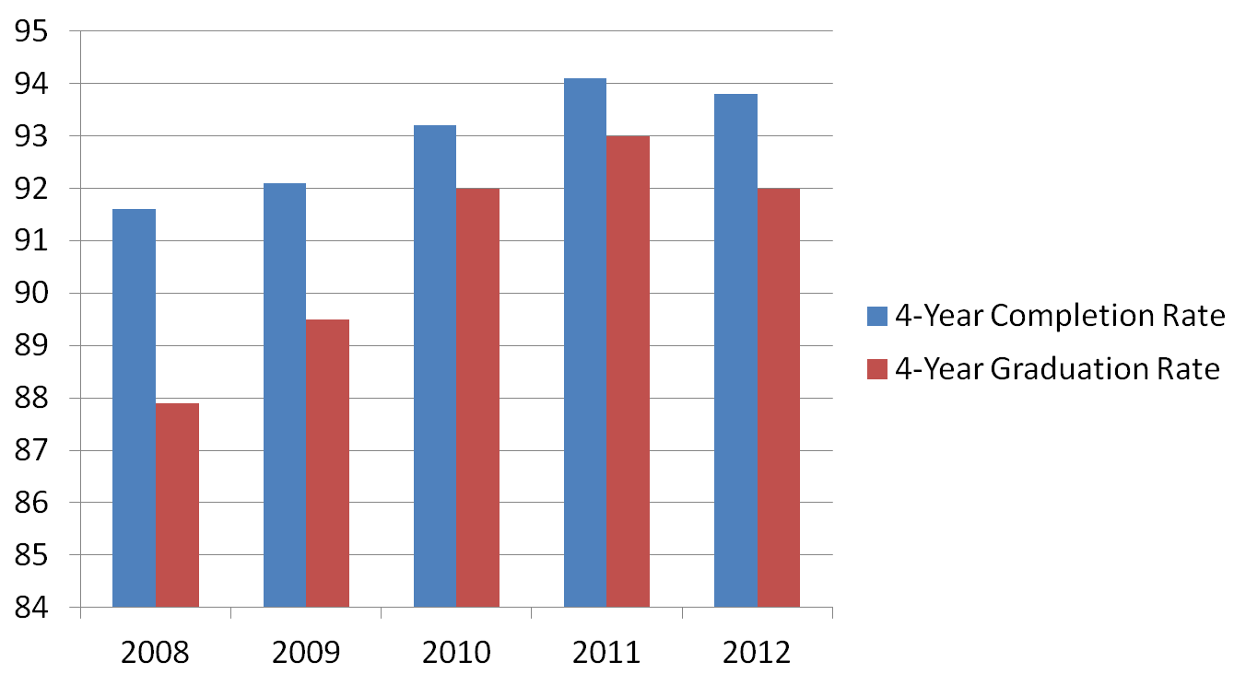

Our quality assurance indicators for this goal will include the following:

- Mastery of the lifelong-learner competencies as evidenced by student performance on the ACPS performance-based assessments/tasks
- Students reading on grade level
- Percentage of students & enrollment groups earning Advanced Studies diplomas
- Rate of ACPS students earning industry certifications
- Student & enrollment group participation rates in the arts
- Student & enrollment group participation rates in sports
- Student & enrollment group participation rates in extra-curricular activities
- Student & enrollment group participation rates in a mentorship or internship prior to graduation
- Student & enrollment group participation rates in volunteer activities
- College and Work Readiness Assessment (CWRA) Report
- Virginia Cohort College Retention Rate published by the Virginia Department of Education (VDOE)
- Other: TBD (Possible ACPS Seal, possible oral language assessment)

ACPS will engage every student in meaningful, authentic and rigorous work through the use of instructional best practices and supportive technologies that will motivate students to be self-directed and inquisitive lifelong learners.
Objective 1– We Will Engage Every Student
Board Priorities:
- 1.1 - Define, develop, and implement effective teaching practices that maximize rigor and meaningful engagement for all students.
- 1.2 – Develop a division-wide master framework for contemporary professional development and training that optimizes our workforce and addresses the essential competencies needed by teachers, administrators, and classified staff.
- 1.3 - Integrate the use of contemporary learning spaces and supportive technologies into the instructional program delivery.
ACPS will implement a balanced assessment system that accurately reflects student demonstration and mastery of our Lifelong-Learner Competencies.
Objective 2 – We Will Implement Balanced Assessments
Board Priorities:
- 2.1 – Define and communicate the Division’s specific measures for mastery of lifelong-learning competencies and student success.
  - Possible Strategy 2.11– Develop an ACPS graduation seal to reflect Division graduation requirements.
- 2.2 - Implement performance-based assessments/tasks and grading practices to create a balanced learning system that measures ACPS outcomes for student success.
  - Possible Strategy 2.21– Expand professional development opportunities for teachers and administrators on developing, using, scoring, and interpreting varied types of assessments to create a balanced assessment system.
ACPS will improve lifelong-learning opportunity and achievement for all students and enrollment groups.
Objective 3 – We Will Improve Opportunity and Achievement
Board Priorities:
- 3.1 - Prepare all students for successful transition to the next grade in their PK-12 experience.
  - Possible Strategy 3.11– Measure and report student and enrollment group performance on key metrics for work and college readiness from K-12 including student performance on ACPS division-wide performance task assessments.
- 3.2 - Implement a robust, Division-wide PK-12 World Languages Program.
  - Possible Strategy 3.21 – Obtain funding from Board of Supervisors and/or community to support a robust, Division-wide PK-12 World Languages Program.
Objective 4 – We Will Create and Expand Partnerships
ACPS will create and expand partnerships with parents, community and business leaders to fulfill their essential roles as actively engaged partners in supporting student achievement and lifelong-learning outcomes for student success.
Board Priorities:
- 4.1 - Implement a comprehensive mentorship and internship program and expand field trip opportunities to provide real-world learning experiences for all students’ success.
- 4.2 – Invest the full community in supporting student achievement and outcomes for all students’ success.
  - Possible Strategy 4.21 – Implement targeted recommendations from the Division’s Strategic Communications Plan.

Objective 5 – We Will Optimize Resources
ACPS will optimize all resources to achieve the school division’s strategic goal and lifelong-learning outcomes for student success.

Board Priorities:
- 5.1 – Ensure the health and safety of the school community.
- 5.2 – Optimize the use of fiscal resources in support of the Division’s strategic plan and operations.
- 5.3 – Design the high school of the future.

